Study 4 S1

Block: Informed Consent (3 Questions)

BlockRandomizer: 1 - Evenly Present Elements

Block: Instructions Warning (10 Questions)

Block: Instructions No Warning (7 Questions)

BlockRandomizer: 1 - Evenly Present Elements

BlockRandomizer: 1 - Evenly Present Elements

Branch: New Branch

If

If Welcome to the study.The following is a consent form for participating in our study. Please read... Is Displayed

EmbeddedData

group = 1A

Standard: Group 1A (3 Questions)

EmbeddedData

theorderValue will be set from Panel or URL.

Branch: New Branch

If

If Welcome to the study.The following is a consent form for participating in our study. Please read... Is Displayed

EmbeddedData

group = 1B

Standard: Group 1B (3 Questions)

EmbeddedData

theorderValue will be set from Panel or URL.

BlockRandomizer: 1 - Evenly Present Elements

Branch: New Branch

If

If Welcome to the study.The following is a consent form for participating in our study. Please read... Is Displayed

EmbeddedData

group = 2A

Block: Group 2A (3 Questions)

EmbeddedData

theorderValue will be set from Panel or URL.

Branch: New Branch

If

If Welcome to the study.The following is a consent form for participating in our study. Please read... Is Displayed

EmbeddedData

group = 2B

Block: Group 2B (3 Questions)

EmbeddedData

theorderValue will be set from Panel or URL.

WebService: GET - http://reporting.qualtrics.com/projects/randomNumGen.php - Fire and Forget

Branch: New Branch

If

If Instructions (Please read!)   In this task, you will see a series of graphs. For each graph, you... Is Displayed

EmbeddedData

subject_condition = warning

Branch: New Branch

If

If Instructions (Please read!)   In this task, you will see a series of graphs. For each graph, you... Is Not Displayed

EmbeddedData

subject_condition = no warning

Standard: Debrief and goodbye (5 Questions)

|  |  |
| --- | --- |
| Page Break |  |

Start of Block: Informed Consent

|  |
| --- |
|  |

consent **I have read this consent form, and I consent to my participation in the research described above.**

* I consent (1)

workerID **Enter your workerID below.**  
*It is important to do so accurately so that we can link your responses together across sessions and confirm your participation.*

________________________________________________________________

End of Block: Informed Consent

Start of Block: Instructions Warning

*welcome to part 1 **Welcome to Part 1**  
    
We are interested in how people interpret graphs about a range of issues. Please read the following instructions carefully.

|  |  |
| --- | --- |
| Page Break |  |

*W_instruction **Instructions (Please read!)**  In this task, you will see a series of graphs. For each graph, you will be asked about the information presented.   
    
Some the graphs were created to be **misleading.**    
    
For example, you might see a graph where the y-axis does not start at 0, as in the graph on the left. We call this technique axis truncation. As you can see, this gives the impression that there is a larger difference in interest rates between 2008 and 2012 than might be warranted.    
   
Don't spend too long on any question. It is okay if some of the topics are unfamiliar to you. Look at the graphs as you would if you encountered them in a newspaper or magazine article.

|  |  |
| --- | --- |
| Page Break |  |

|  |
| --- |
|  |

manipulation_check   
 **Quick Check** Click the graph below that was designed to be misleading.

* **Graph #1**   (6)
* **Graph #2**   (7)

|  |  |
| --- | --- |
| Page Break |  |

Display This Question:

If Quick Check Click the graph below that was designed to be misleading.   = <strong>Graph #2</strong>

correct **CORRECT!**   
Nice job! Graph #2 was designed to be misleading because the y-axis does not start at 0.   
    
**Graph #1**   
  
   
     
    
**Graph #2**

|  |  |
| --- | --- |
| Page Break |  |

Display This Question:

If Quick Check Click the graph below that was designed to be misleading.   = <strong>Graph #1</strong>

incorrect **X INCORRECT.**  
 Actually, the second graph is more misleading because the vertical axis of **graph #2 does not start at 0**.   
   
   
  
 **Graph #1**   
  
   
     
    
**Graph #2**​​   
*​*

|  |  |
| --- | --- |
| Page Break |  |

*trial **Sample Trial**  
  
This an example of what you'll see in our study. Make a choice based on the graph.

*trial

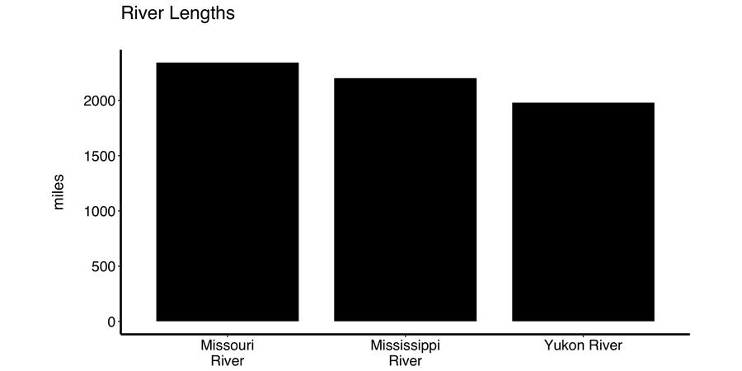

trial_rating Compare the lengths of the Yukon River and the Missouri River. How different are they?

* 1 not at all different (1)
* 2 (2)
* 3 (3)
* 4 moderately different (4)
* 5 (5)
* 6 (6)
* 7 extremely different (7)

|  |  |
| --- | --- |
| Page Break |  |

|  |
| --- |
|  |

*good_job **Great job!** Now you will complete the remainder of the study.  
  
  
We ask that you stay within the survey window for the duration of the study for the integrity of our research.

End of Block: Instructions Warning

Start of Block: Instructions No Warning

*welcome to part 1 **Welcome to Part 1**  
    
We are interested in how people interpret graphs about a range of issues. Please read the following instructions carefully.

|  |  |
| --- | --- |
| Page Break |  |

*NW_instructions **Instructions** In this task, you will see a series of graphs. For each graph, you will be asked about the information presented.   
  
  
Don't spend too long on any question. It is okay if some of the topics are unfamiliar to you. Look at the graphs as you would if you encountered them in a newspaper or magazine article.

timing_instructions Timing

First Click (1)

Last Click (2)

Page Submit (3)

Click Count (4)

|  |  |
| --- | --- |
| Page Break |  |

trial **Sample Trial**  
  
This an example of what you'll see in our study. Make a choice based on the graph.

trial



trial_rating Compare the lengths of the Yukon River and the Missouri River. How different are they?

* 1 not at all different (1)
* 2 (2)
* 3 (3)
* 4 moderately different (4)
* 5 (5)
* 6 (6)
* 7 extremely different (7)

|  |  |
| --- | --- |
| Page Break |  |

|  |
| --- |
|  |

good_job **Great job!** Now you will complete the remainder of the study.  
  
  
We ask that you stay within the survey window for the duration of the study for the integrity of our research.

End of Block: Instructions No Warning

Start of Block: Group 1A

1A Look at the following graph:

|  |
| --- |
|  |

rating_1A Compare the ${lm://Field/2} **${lm://Field/3}** and **${lm://Field/4}**. How different are they?

* ${trial_rating/ChoiceDescription/1} (1)
* ${trial_rating/ChoiceDescription/2} (2)
* ${trial_rating/ChoiceDescription/3} (3)
* ${trial_rating/ChoiceDescription/4} (4)
* ${trial_rating/ChoiceDescription/5} (5)
* ${trial_rating/ChoiceDescription/6} (6)
* ${trial_rating/ChoiceDescription/7} (7)

timing_1A Timing

First Click (1)

Last Click (2)

Page Submit (3)

Click Count (4)

End of Block: Group 1A

Start of Block: Group 1B

1B Look at the following graph:

|  |
| --- |
|  |

rating_1B Compare the ${lm://Field/2} **${lm://Field/3}** and **${lm://Field/4}**. How different are they?

* ${trial_rating/ChoiceDescription/1} (1)
* ${trial_rating/ChoiceDescription/2} (2)
* ${trial_rating/ChoiceDescription/3} (3)
* ${trial_rating/ChoiceDescription/4} (4)
* ${trial_rating/ChoiceDescription/5} (5)
* ${trial_rating/ChoiceDescription/6} (6)
* ${trial_rating/ChoiceDescription/7} (7)

timing_1B Timing

First Click (1)

Last Click (2)

Page Submit (3)

Click Count (4)

End of Block: Group 1B

Start of Block: Group 2A

2A Look at the following graph:

|  |
| --- |
|  |

rating_2A Compare the ${lm://Field/2} **${lm://Field/3}** and **${lm://Field/4}**. How different are they?

* ${trial_rating/ChoiceDescription/1} (1)
* ${trial_rating/ChoiceDescription/2} (2)
* ${trial_rating/ChoiceDescription/3} (3)
* ${trial_rating/ChoiceDescription/4} (4)
* ${trial_rating/ChoiceDescription/5} (5)
* ${trial_rating/ChoiceDescription/6} (6)
* ${trial_rating/ChoiceDescription/7} (7)

timing_2A Timing

First Click (1)

Last Click (2)

Page Submit (3)

Click Count (4)

End of Block: Group 2A

Start of Block: Group 2B

2B Look at the following graph:

|  |
| --- |
|  |

rating_2B Compare the ${lm://Field/2} **${lm://Field/3}** and **${lm://Field/4}**. How different are they?

* ${trial_rating/ChoiceDescription/1} (1)
* ${trial_rating/ChoiceDescription/2} (2)
* ${trial_rating/ChoiceDescription/3} (3)
* ${trial_rating/ChoiceDescription/4} (4)
* ${trial_rating/ChoiceDescription/5} (5)
* ${trial_rating/ChoiceDescription/6} (6)
* ${trial_rating/ChoiceDescription/7} (7)

timing_2B Timing

First Click (1)

Last Click (2)

Page Submit (3)

Click Count (4)

End of Block: Group 2B

Start of Block: Debrief and goodbye

*   
Nice job!  
  
Finally, you will answer a few questions about the survey experience.  
  
  
Your responses to these questions will help us interpret our data set. Remember that all information you provide is confidential and your name will not appear on this document. Answering these question is voluntary and you can choose to skip any or all of them.

|  |  |
| --- | --- |
| Page Break |  |

|  |
| --- |
|  |

db_approach Which of the following best describes your approach to answering questions about the graphs? You may select one, more than one, or none at all.  
  
  
**Note**: There is no "wrong answer," and  you may not have used any of these approaches.

* Comparing the values of the bars based on vertical axis (y-axis) (1)
* Comparing the areas of the bars visually (2)
* Using hands, fingers, or other physical objects to measure the heights of bars (3)
* Judging intuitively how different the bars look i.e. how different they "feel" (4)
* Using what I already knew about the topics to answer some of the questions (e.g. I already knew about the weights of brown bears versus cows) (5)
* Other: (6) ________________________________________________

Display This Question:

If Instructions (Please read!)   In this task, you will see a series of graphs. For each graph, you... Is Displayed

db_strategy_w   
We are interested in how people might be approaching graphs that are misleading differently or not differently than accurate graphs.  
  
  
How would you describe your approach to graphs that were misleading?    
  
  
If you have any other comments on your experience with these graphs, you may write them here.

________________________________________________________________

________________________________________________________________

________________________________________________________________

________________________________________________________________

________________________________________________________________

Display This Question:

If Instructions (Please read!)   In this task, you will see a series of graphs. For each graph, you... Is Displayed

db_approach_nw Did you notice anything interesting about the graphs?  
  
  
If you have any other comments on your experience looking at the graphs, you may write them here.

________________________________________________________________

________________________________________________________________

________________________________________________________________

________________________________________________________________

________________________________________________________________

|  |  |
| --- | --- |
| Page Break |  |

|  |
| --- |
|  |

*   
**Thank you for participating in Part 1**  
   
 **Don't forget to come back tomorrow for Part 2**   
Look out for an email tomorrow, starting at noon EST, where we will let you know that the second part is available. If you cannot find the email, check MTurk for a HIT called "Looking at Graphs (Part 2 of 2)"   
  
 **To finish this HIT**   
Please put the following unique code into your MTurk survey:  
   
**C${e://Field/mTurkCode}**  
   
 **Comments or problems?**  
If you have any comments or thoughts on your experience, we welcome them in the "Comments" section on the MTurk form. If you have problems finding the second session tomorrow, please email marshlab@duke.edu.   
  
  
Have a nice day!

End of Block: Debrief and goodbye